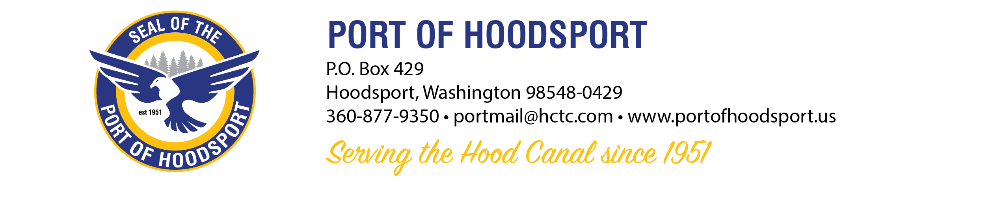
Port of Hoodsport Park/Waterfront Park/Marina Dock

Event Application Form

Date: _______________

Event Sponsor & Name of Event (Facility User): __________________________________________________________________________________________________________________________________________________________

Contact Information:
Direct Contact: _______________________________________________________________
Email Address: ________________________________________________________________
Phone: __________________________________________________

Event Date Requested: _______________________________________
Start Time/ End Time: _______________________________________
Number of People attending: __________________________________
Special Requests: ______________________________________________________________
Precautions (if any) in place as per Federal/State/County guidelines: __________________________________________________________________________________________________________________________________________________________

Brief description of event: ______________________________________________________________________________________________________________________________________________________________________________________________________________________________________________________________________________________________________________________________________________________________________________________________________________________________________________________________________________

Required:
1. $100.00 nonrefundable deposit reservation fee for approved Sponsored events
2. Event application submitted at least 4 months prior to event for commission approval
3. Facility Use Agreement must be approved and mutually signed by the port commission and event sponsor 3 months prior to event.
4. Certificates of Liability Insurance from each Vendor at your event as specified on the Facility Use Agreement in each organization’s names and evidence of current liability insurance for specific types of liabilities for this event naming the Port of Hoodsport and WA State DNR as additionally insured with $2,000,000.00 liability limits and coverages.
submitted at least 2 months prior to the event.
If applicable **Certificates of Liability from Each Participating Vendor Must be Received by the Port of Hoodsport One Month Prior to the Event.

*Preferred method of correspondence is via email at:
portmail@hctc.com

Port of Hoodsport
360-877-9350
24113 N Hwy 101 Suite A
P.O.Box 429 (mailing address)
Hoodsport, WA 98548-0429
E-mail portmail@hctc.com

REQUEST APPROVED & CONDITIONS:
_______________________________________________________________________________________________________________________________________________________________________________________________________________________________________________________________
REQUEST DENIED & REASONS:

_______________________________________________________________________________________________________________________________________________________________________________________________________________________________________________________________

2 event.application.doc

